CHAPTER – 5

DESIGN AND DEVELOPMENT

#### Project description

#### Platform

#### Module description

#### 5.1Project Description

#### 

#### The above figure illustrates the working of all over the project.

#### Different types of the sensors are placed in the environment which sense the environment around them and according to that it sends signals to microcontroller.

#### The Microcontroller sense the signal and take appropriate action according to the condition.

#### The Microcontroller control other devices and also send the data online to the database which is used further for website and mobile application which gives real time update of the particular module.

#### Components used:

* + - 1. Arduino Microcontroller
      2. NodeMCU Microcontroller
      3. ESP 8266
      4. Relay Module
      5. LDR Sensor
      6. Water level sensor
      7. Ultrasonic Sensor
      8. LED
      9. LCD display
* **Arduino Uno:**

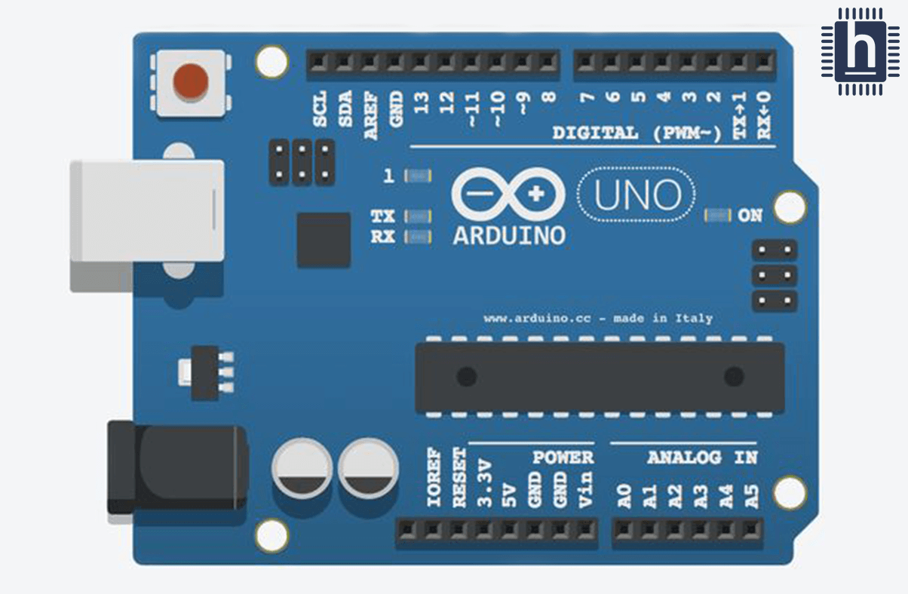

* + Arduino Uno microcontroller board is based on ATmega328P.It has 14 digital input/output pins, 6 analog inputs, a 16 MHz ceramic resonator, a USB connection, a power jack and a reset button. It requires 5 V power supply to activate.
  + We program this microcontroller using Arduino IDE to control all different types of sensors and modules etc.
* **NodeMCU**

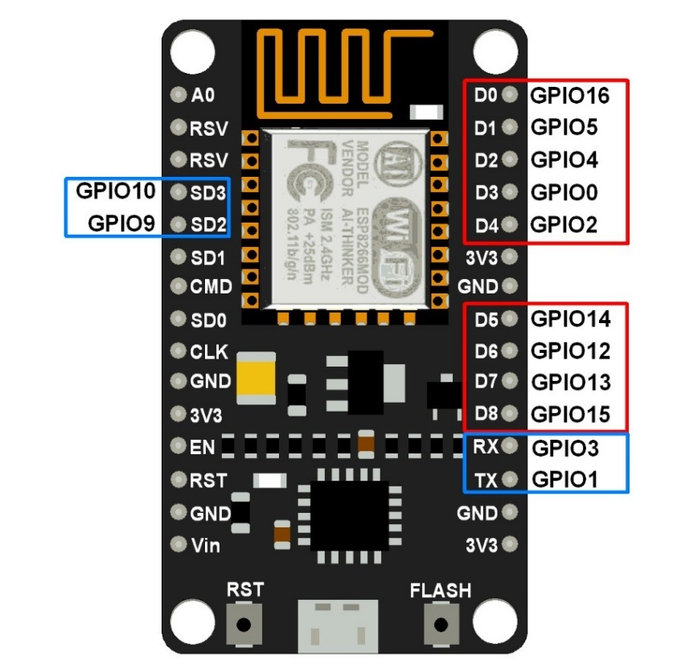

* NodeMCU is also one kind of Microcontroller but what makes NodeMCU so special is that it has in-built Wi-fi Chip.
* NodeMCU has built-in Wifi Module which saves lots of efforts of the developer and makes it easy to connect to the cloud for the developer.
* It also has different GPIO pin which is used as digital pins for sensing he input signal and output pins are used for output purpose.
* **ESP-8266 Wi-Fi Module:**

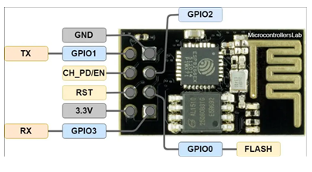

* + ESP-8266 Wi-Fi Module is the main component of our project. It connects our Microcontroller and electronic sensor or module to internet. Using this microcontroller can send the data to database and receive the data from database.
  + In Arduino Microprocessor we need to interface esp-8266 externally and it can be controlled from local Wi-Fi network or internet.
* **Relay Module**

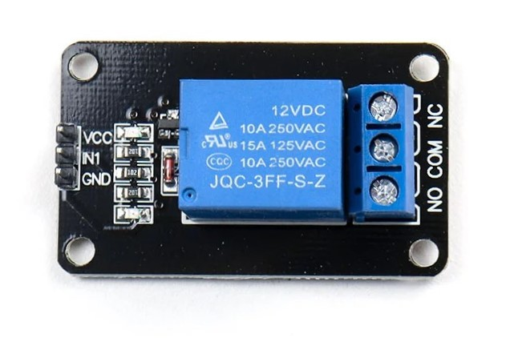

* Relay Module is one kind of mechanical switch which works on 5v to 12v.
* It controls other devices with the help of signal which it receives.
* The relay module separate two different system from each other which work on different voltages.
* **Ultrasonic sensors:**

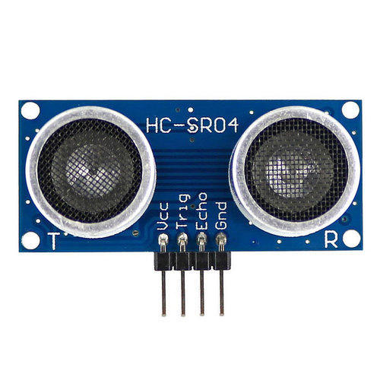

* + Ultrasonic sensor is an electronic device that measure the distance of object by sending ultrasonic sound wave. It has two components.one is transmitter and second is receiver. Transmitter send ultrasonic wave and receiver receives ultrasonic wave. Transmitter send ultrasonic wave and if any object is in front of ultrasonic sensor than the wave is reflected and received by receiver.
  + In order to calculate the distance between the sensor and object, the formula is D=(T*C)/2 where, D is the distance, T is the time, and C is the speed of sound ~ 343 meters/second.
* **LDR Sensor:**

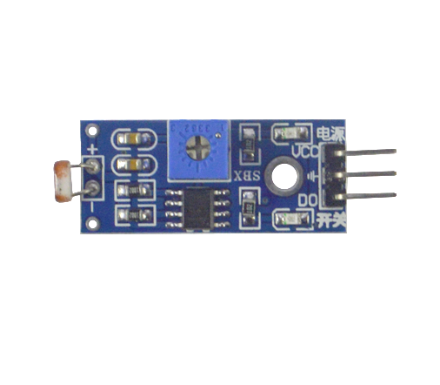

* + LDR sensor is also called photoresistor sensor. When lights fall on it then it gives low signal to the microprocessor if there is not then it gives HIGH signal to microprocessor.
* **LED:**
  + Led is used for the lighting purpose. In our project depends on the current status of Motion Sensor and LDR Sensor it will turn OFF and ON.
* **LCD Display:**

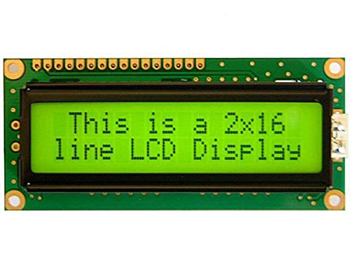

* + LCD require 5v current to operate. LCD used for displaying the data on the screen and it is connected to the microcontroller and depends on program it gives the displaying the data on screen. It can be also used for reading and writing.

#### Platforms:

#### Arduino IDE

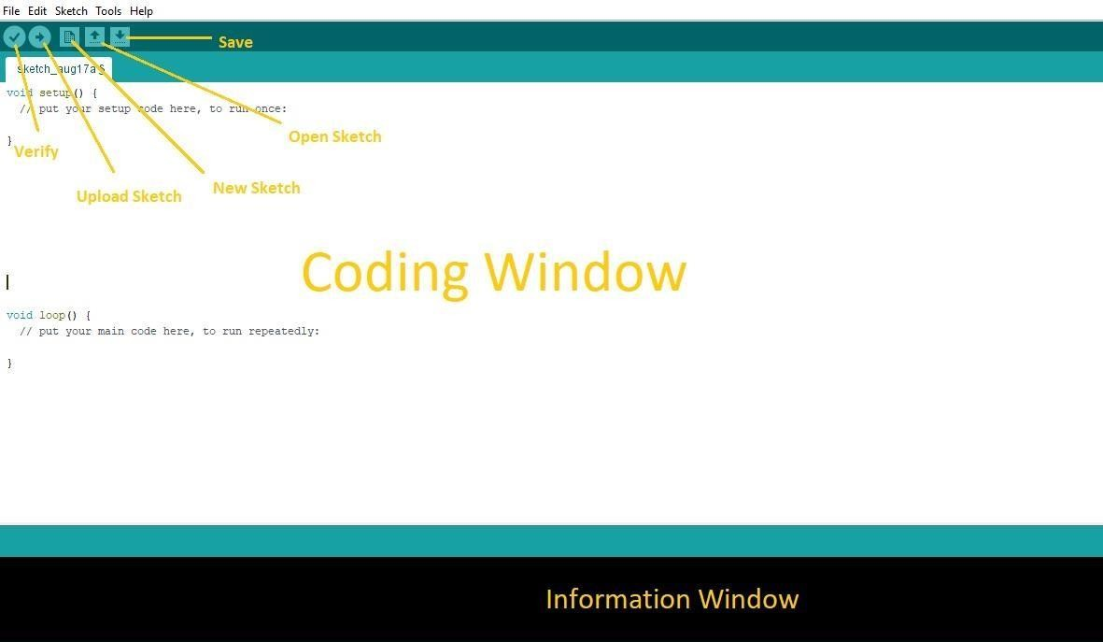

* The Arduino IDE is the tool, which we used to program the micro- controller of the Arduino.
* Arduino software is easy to use and free open source also available for all operating system like Windows, Linux, and Mac etc.
* That software is based on C++ and we can easily write and verify, upload the program in Arduino board.

**Language:** Arduino (Consists: Java, Python, C++, C, etc.)